Name: Bradley Willcott

ID: M198449

Date: 11 September 2021

Assessment Task – Project

Web Programming

Contents

Figures 2

Project Analysis 3

Development and Production environments 3

The Development Environment 3

Functional Design and Architectural requirements 4

Architectural requirements 4

Prototype of Website UI Design 5

Database Design 8

HTML elements and CSS 9

darkstyle.css 9

navbar.css 16

Run Website 19

References 47

Tables

Table 1: Test results 19

# Figures

Figure 1 - Home page 5

Figure 2 – Movie Search page 5

Figure 3 – Top Ten page 6

Figure 4 - About page 6

Figure 5 - License page 7

Figure 6 - Data Diagram 8

Figure 7 – Home page 20

Figure 8 – Add User page - A 20

Figure 9 – Add User page - B 21

Figure 10 – Add user - A 21

Figure 11 – Add user - B 22

Figure 12 - Add user - C, confirmation 22

Figure 13 - Partial entry - A 23

Figure 14 - Partial entry - B 23

Figure 15 - Partial entry - C 24

Figure 16 - Partial entry - D 24

Figure 17 - Invalid email - A 25

Figure 18 - Invalid email - B 25

Figure 19 - Invalid email - C 26

Figure 20 - Invalid text in First name 26

Figure 21 - Invalid text in Last name 27

Figure 22 - Go to List Users page 28

Figure 23 - List Users 29

Figure 24 - Home page 30

Figure 25 - Display Add User page - A 31

Figure 26 - Display Add User page - B 32

Figure 27 - Add user - A 33

Figure 28 - Add user - B 34

Figure 29 - Add user - C, confirmation 35

Figure 30 - Partial data - A 36

Figure 31 - Partial data - B 37

Figure 32 - Partial data - C 38

Figure 33 - Partial data - D 39

Figure 34 - Invalid email - A 40

Figure 35 - Invalid email - B 41

Figure 36 - Invalid email - C 42

Figure 37 - Invalid text in First name 43

Figure 38 - Invalid text in Last name 44

Figure 39 - List all users 45

# Project Analysis

## Development and Production environments

### The Development Environment

The development environment consists of multiple tools across two operating systems. Firstly, the primary development work is to be done using tools within the Linux operating system. Thought these, or similar, tools are available under other operating systems, Linux (specifically Fedora 34) is my preferred system.

The tools include the following:

* Development (Linux)
  + Netbeans (v12.4) with various PHP and HTML plugins installed
  + A PHP application project – the website project
  + A Maven Java application project – a tool to prototype the website with
  + XAMPP (8.0.7-0) with Apache Web Server and MySQL (MariaDB) database
* Testing
  + Linux
    - Firefox browser
  + Microsoft Windows 10
    - Microsoft Edge
* Documentation (Microsoft Windows)
  + Microsoft Word
* Production (Linux)
  + MySQL database
  + Apache Web server with PHP modules

## Functional Design and Architectural requirements

* Add user page
  + Will accept:
    - Name
    - Email
  + Information to be stored in a database
  + Data validation:
    - Name: regex => “[a-zA-Z]+([ ‘-]?[a-zA-Z]+)*”
    - Email: syntax ~><name>@<domain>
      * <name>: ”[a-zA-Z]+(\.[a-zA-Z0-9]+)*”
      * <domain>: ”[a-z]+[0-9]* (\.[a-z]+)*”
* Show all users page:
  + Display all the users created

### Architectural requirements

The Membership website must include navigation of:

* Add a user
* Show all users

## Prototype of Website UI Design

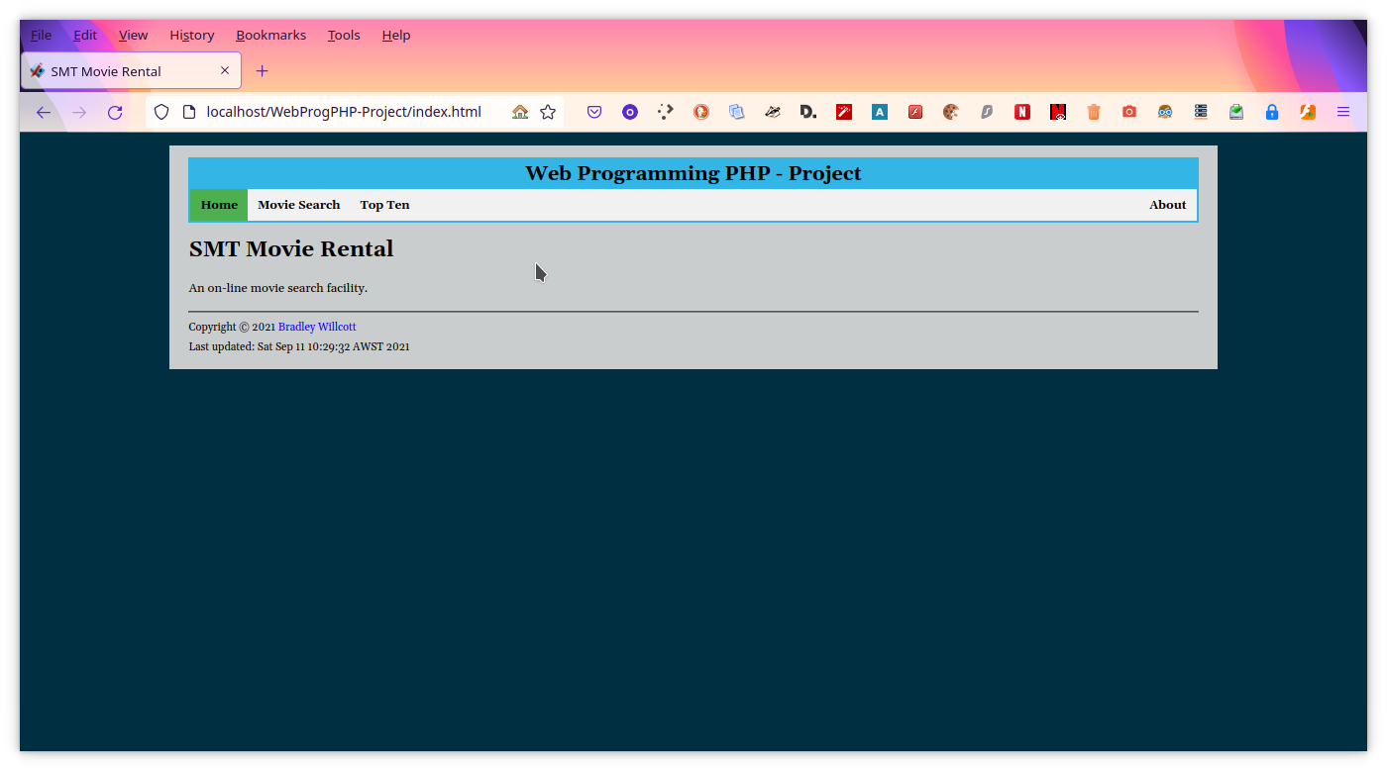

Figure 1 - Home page

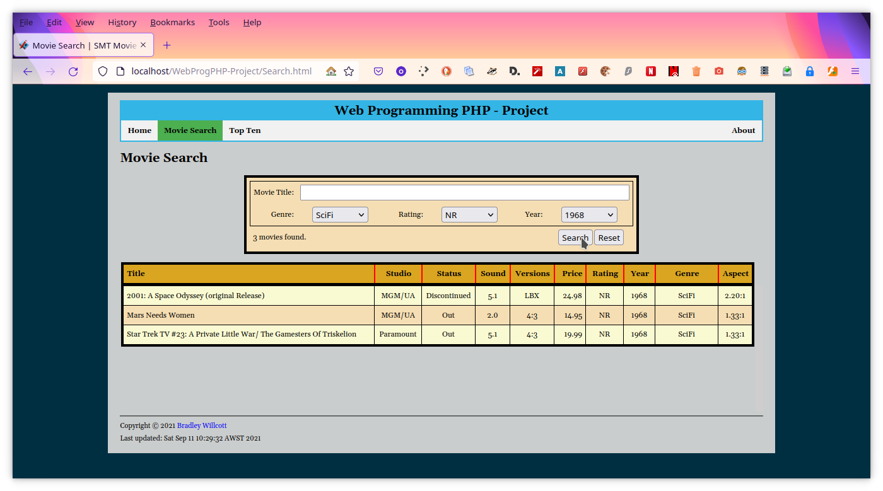

Figure 2 – Movie Search page

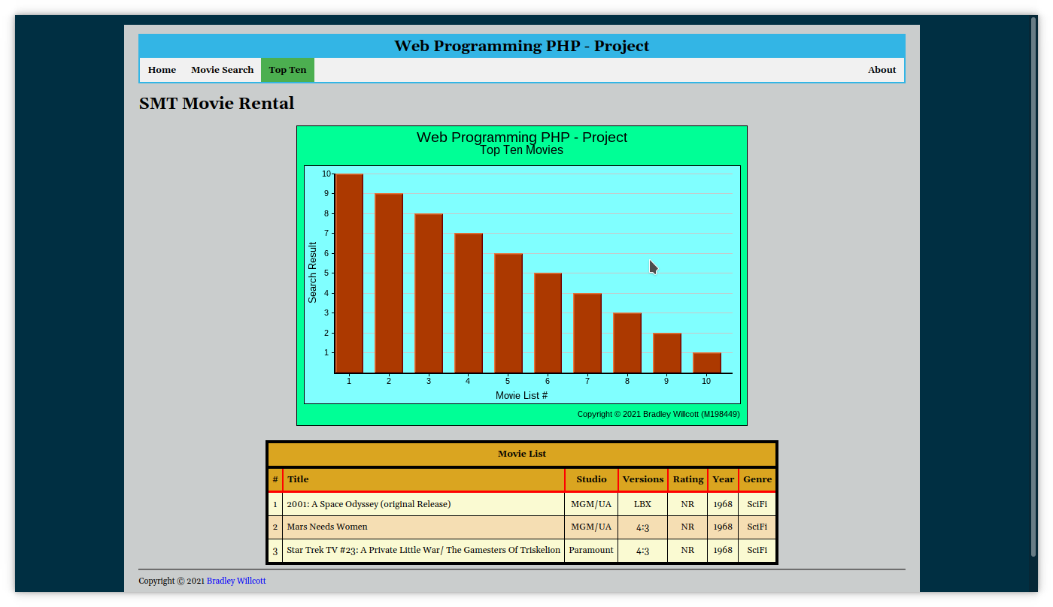

Figure 3 – Top Ten page

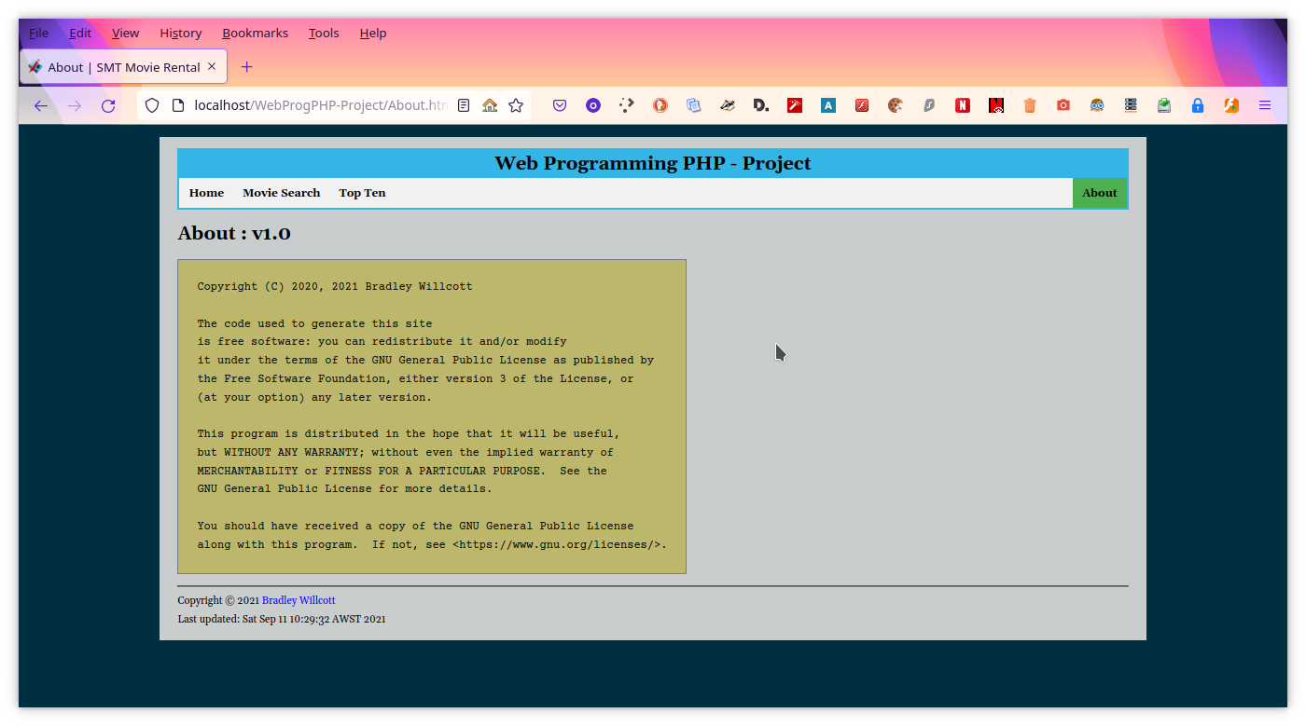

Figure 4 - About page

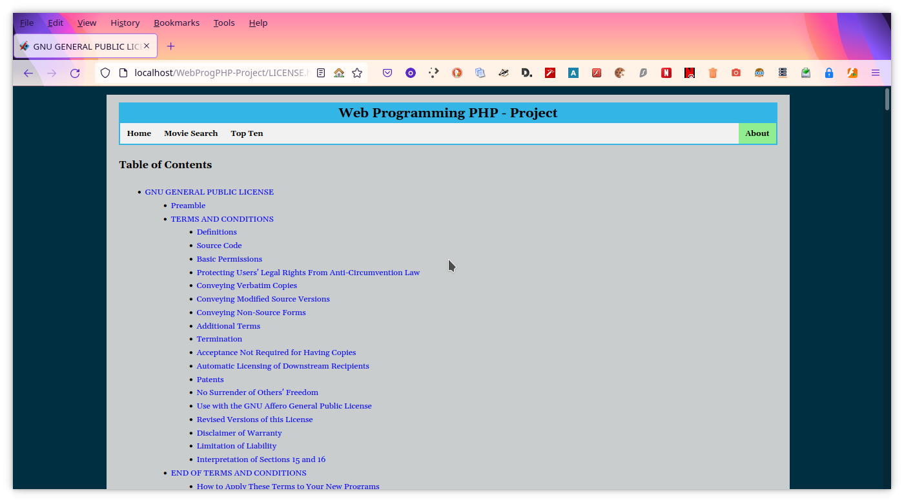

Figure 5 - License page

## Database Design

Figure - Data Diagram

## HTML elements and CSS

The following are samples of the HTML 5 form elements that will be used:

* <form action="Search.html" method="post">
  + <label for="title">Movie Title:</label>
  + <input type="text" id="title" name="title" size="60">
  + <select name="genre" id="genre">
    - <option value="Anime">Anime</option>
  + <input type="submit" value="Search">
  + <input type="reset" value="Reset">

The following is a copy of each of the two stylesheets to be used:

### darkstyle.css

/*

Copyright (C) 2020, 2021 Bradley Willcott

This program is free software: you can redistribute it and/or modify

it under the terms of the GNU General Public License as published by

the Free Software Foundation, either version 3 of the License, or

(at your option) any later version.

This program is distributed in the hope that it will be useful,

but WITHOUT ANY WARRANTY; without even the implied warranty of

MERCHANTABILITY or FITNESS FOR A PARTICULAR PURPOSE. See the

GNU General Public License for more details.

You should have received a copy of the GNU General Public License

along with this program. If not, see <http://www.gnu.org/licenses/>.

*/

/*

Created on : 1 Mar 2020, 2:28:15 AM

Author : Bradley Willcott

*/

article, footer {

display: block;

}

article {

color: black;

background: #cacdcd;

margin: 1em auto;

padding: 1em 1.5em;

max-width: 80em;

font-family: PT Serif, Georgia;

line-height: 155%;

text-align: left;

font-size: 98%;

}

div.blockquote {

font-style: italic;

border-left: thick solid;

padding-top: 3px;

padding-left: 20px;

padding-bottom: 20px;

margin: 1em;

}

div.blockquote a.cite {

font-style: normal;

color: inherit;

padding: 4px;

box-shadow: 2px 3px;

}

div.blockquote a.cite:hover {

box-shadow: 1px 2px dodgerblue;

}

div.blockquote a.cite:active {

box-shadow: 1px 2px lime;

}

body {

background-color:#002f42;

color:#353833;

font-family: Arial, Helvetica, sans-serif;

font-size:13px;

}

header {

background-color: #33b5e5;

display: block;

font-size:18px;

text-align: center;

margin: 0;

padding: 10px;

font-weight: bold;

}

footer {

font-size:11px;

}

h1 {

font-size:22px;

}

h2 {

font-size:20px;

}

h3 {

font-size:18px;

}

h4 {

font-size:16px;

}

h5 {

font-size:14px;

}

h6 {

font-size:13px;

}

hr.bold {

border-width: 3px;

}

hr.thick {

border-width: 2px;

}

ul {

list-style-type:disc;

}

ul.checkbox {

list-style-type: none;

margin-left: 2.5em;

padding-left: 0.0em;

}

ul.terms {

margin-left: 0;

padding-left: 0;

}

ul.terms > li {

list-style-type: none;

list-style-position: inside;

margin-top: 5px;

font-weight: bold;

}

ul.terms > li > ul {

margin-left: 0;

padding-left: 0;

}

ul.terms > li > ul > li {

list-style-type: none;

list-style-position: inside;

font-weight: normal;

}

ul.terms ul ul li {

list-style: disc;

}

table {

border: 4px solid black;

border-collapse: collapse;

font-size: 12px;

}

table.centre {

margin-left: auto;

margin-right: auto;

}

table.hidden {

border: 0px;

}

table.hidden th {

border: 0px;

background-color: transparent;

}

table.hidden td {

border: 0px;

background-color: transparent;

}

table.hidden colgroup.border {

border: 1px solid black;

}

caption {

border-left: 4px solid black;

border-top: 4px solid black;

border-right: 4px solid black;

padding: 5px;

background-color: goldenrod;

font-weight: bold;

}

th {

border-left: 2px solid red;

border-right: 2px solid red;

border-bottom: 3px solid red;

padding: 5px;

text-align: center;

background-color: goldenrod;

}

td {

background-color: lightgoldenrodyellow;

border: 1px solid black;

padding: 5px;

}

td.alt {

background-color: wheat;

}

td.reset {

}

td.total {

background-color: pink;

font-weight: bold;

border: 2px solid red;

padding: 5px;

}

pre {

font-family: 'Courier New', monospace;

font-size: 12px;

background-color: darkkhaki;

display:table;

padding: 0px 20px;

border: 1px solid slategray;

}

pre code {

border: none;

padding: 0px;

margin: 0px;

background-color: darkkhaki;

}

code {

font-family: 'Courier New', monospace;

background-color: #eff0f0;

font-size: 12px;

padding: 0px 2px;

margin-top:4px;

line-height: 1.0em;

border: 1px solid slategray;

}

table code{

background-color: #eff0f0;

}

a {

color: blue;

text-decoration: none;

}

a:hover {

color: dodgerblue;

}

a:active {

color: limegreen;

}

a.externalLink {

background: url(../etc/external.png) right center no-repeat;

background-size: auto 9px;

padding: 10px;

margin-right: 1px;

}

a.externalLink:hover {

background-size: auto 12px;

padding-top: 11px;

padding-right: 11px;

margin-right: 0;

}

a.externalLink:active {

background-size: auto 9px;

padding: 10px;

margin-right: 1px;

}

a.newTab {

background: url(../etc/newtab.png) right center no-repeat;

background-size: auto 9px;

padding: 10px;

margin-right: 1px;

}

a.newTab:hover {

background-size: auto 12px;

padding-top: 11px;

padding-right: 11px;

margin-right: 0;

}

a.newTab:active {

background-size: auto 9px;

padding: 10px;

margin-right: 1px;

}

a.next {

background: url(../etc/16px-arrow-right.png) right center no-repeat;

background-size: auto 12px;

padding: 12px;

margin-right: 1px;

}

a.next:hover {

background-size: auto 15px;

padding-top: 13px;

padding-right: 13px;

margin-right: 0;

}

a.next:active {

background-size: auto 12px;

padding: 12px;

margin-right: 1px;

}

a.previous {

background: url(../etc/32px-Go-previous.png) right center no-repeat;

background-size: auto 25px;

margin-left: 5px;

margin-right: 5px;

}

a.previous:hover {

background-size: auto 28px;

margin-left: 6px;

margin-right: 4px;

}

a.previous:active {

background-size: auto 25px;

margin-left: 5px;

margin-right: 5px;

}

a.upArrow {

background: url(../etc/16px-arrow-up.png) right center no-repeat;

background-size: auto 14px;

padding: 10px;

margin-right: 1px;

}

a.upArrow:hover {

background-size: auto 17px;

padding-top: 11px;

padding-right: 11px;

margin-right: 0;

}

a.upArrow:active {

background-size: auto 14px;

padding: 10px;

margin-right: 1px;

}

sup {

vertical-align: super;

font-size: smaller;

font-style: normal;

}

.centre{

text-align: center;

}

.error {

color: red;

}

.quote {

font-style: italic;

}

.right {

text-align: right;

}

### navbar.css

/*

Copyright (C) 2021 Bradley Willcott

This program is free software: you can redistribute it and/or modify

it under the terms of the GNU General Public License as published by

the Free Software Foundation, either version 3 of the License, or

(at your option) any later version.

This program is distributed in the hope that it will be useful,

but WITHOUT ANY WARRANTY; without even the implied warranty of

MERCHANTABILITY or FITNESS FOR A PARTICULAR PURPOSE. See the

GNU General Public License for more details.

You should have received a copy of the GNU General Public License

along with this program. If not, see <http://www.gnu.org/licenses/>.

*/

/*

Created on : 15 Jan 2021, 11:36:41 am

Author : <a href="mailto:bw.opensource@yahoo.com">Bradley Willcott</a>

*/

#navbar ul {

font-size:12px;

list-style: none;

margin: 0;

padding: 0;

background-color: #f1f1f1;

}

#navbar ul li {

float: left;

list-style: none;

position: relative;

margin: 0;

padding: 0;

}

#navbar ul li.right {

float: right;

}

/* main level link */

#navbar ul a {

display: inline-block;

color: black;

text-align: center;

padding: 6px 10px;

margin: 0;

text-decoration: none;

white-space: nowrap;

}

#navbar ul li.active{

background-color: #4CAF50;

}

#navbar ul li.subactive{

background-color: lightgreen;

}

#navbar a.previous {

display: block;

height: 19px;

width: 8px;

margin-left: 3px;

margin-right: 5px;

}

#navbar a.previous:hover {

height: 18px;

margin-left: 4px;

margin-right: 4px;

}

#navbar a.previous:active {

margin-left: 3px;

margin-right: 5px;

}

/* main level link hover */

#navbar ul > li:not(.active) > a:not(.previous):hover {

background-color: #555;

color: white;

}

/* sub levels dropdown */

#navbar ul li:hover > ul {

display: block;

}

/* level 2 list */

#navbar ul ul {

display: none;

position: absolute;

margin: 0;

padding: 0;

background-color: #f9f9f9;

box-shadow: 0px 8px 16px 0px rgba(0,0,0,0.2);

z-index: 1;

}

#navbar ul ul a {

display: block;

text-align: left;

}

#navbar ul ul li {

float: none;

}

/* level 3+ list */

#navbar ul ul li:hover > ul {

display: block;

}

#navbar ul ul ul {

left: 98%;

top: 10%;

}

/* clearfix */

#navbar ul:after {

content: ".";

display: block;

clear: both;

visibility: hidden;

line-height: 0;

height: 0;

}

#navbar ul {

display: block;

}

html[xmlns] #navbar ul {

display: block;

}

* html #navbar ul {

height: 1%;

}

@media screen and (max-width: 600px) {

#navbar ul ul li.right,

#navbar ul ul li {float: none;}

}

header {

padding: 2px;

}

header p {

font-size:20px;

margin: 0;

padding: 5px;

font-weight: bold;

}

# Run Website

Table : Test results

|  |  |  |  |  |
| --- | --- | --- | --- | --- |
| Case | Description | Expected | Actual | Evidence |
|  | Test using FireFox: |  |  |  |
| #1 | Home page | Display Home page | As expected | Figure 7 |
| #2 | Add User page | Display Add User page | As expected | Figure 8  Figure 9 |
| #3 | Add new user: Mary Mills,  mmills@gmail.com | New user added | As expected | Figure 10  Figure 11  Figure 12 |
| #4 | Add partial data:  Greg Jones, no email | Message displayed, no record added | As expected | Figure 13  Figure 14  Figure 15  Figure 16 |
| #5 | Invalid email | HTML 5 message,  No new record. | As expected | Figure 17  Figure 18  Figure 19 |
| #6 | Invalid text in First name | Display error message | As expected | Figure 20 |
| #7 | Invalid text in Last name | Display error message | As expected | Figure 21 |
| #8 | List users | Display the list of current users | As expected | Figure 22  Figure 23 |
|  | Test using MS Edge: |  |  |  |
| #9 | Home page | Display Home page | As expected | Figure 24 |
| #10 | Add User page | Display Add User page | As expected | Figure 25  Figure 26 |
| #11 | Add new user:  Sally Mills,  Sally.mills@gmail.com | New user added | As expected | Figure 27  Figure 28  Figure 29 |
| #12 | Add partial data:  Harry Redmond, no email | Message displayed,  no record added | As expected | Figure 30  Figure 31  Figure 32  Figure 33 |
| #13 | Invalid email | HTML 5 message,  No new record. | As expected | Figure 34  Figure 35  Figure 36 |
| #14 | Invalid text in First name | Display error message | As expected | Figure 37 |
| #15 | Invalid text in Last name | Display error message | As expected | Figure 38 |
| #16 | List all users | Display List Users page | As expected | Figure 39 |

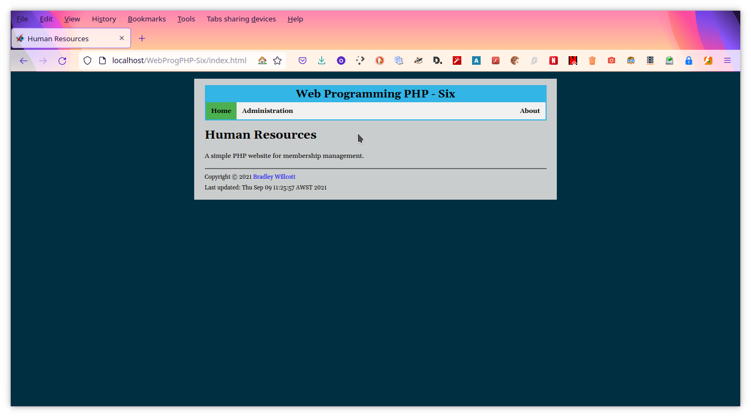

Figure – Home page

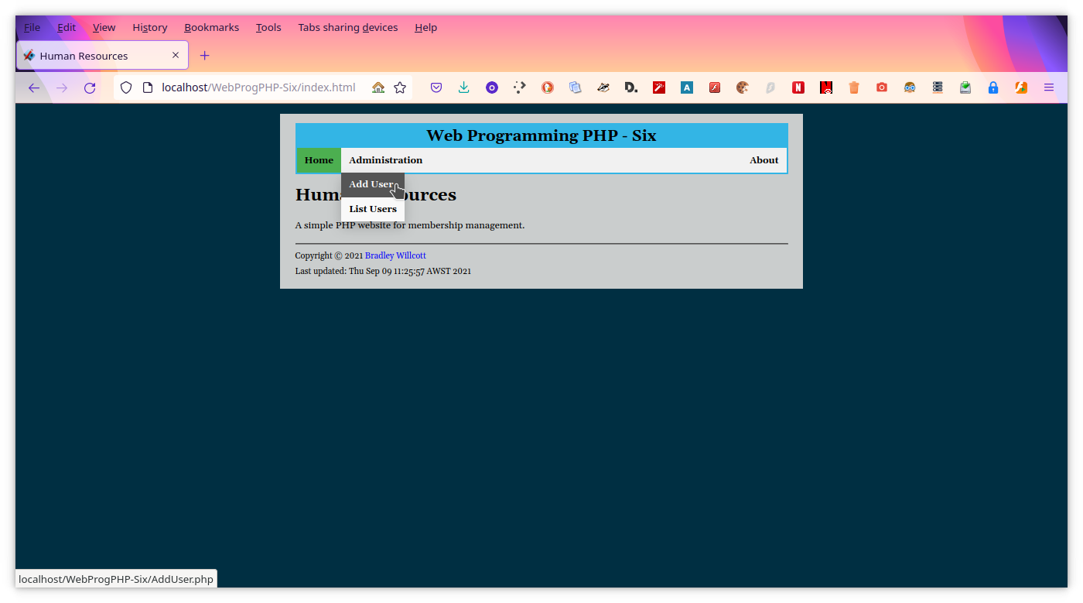

Figure – Add User page - A

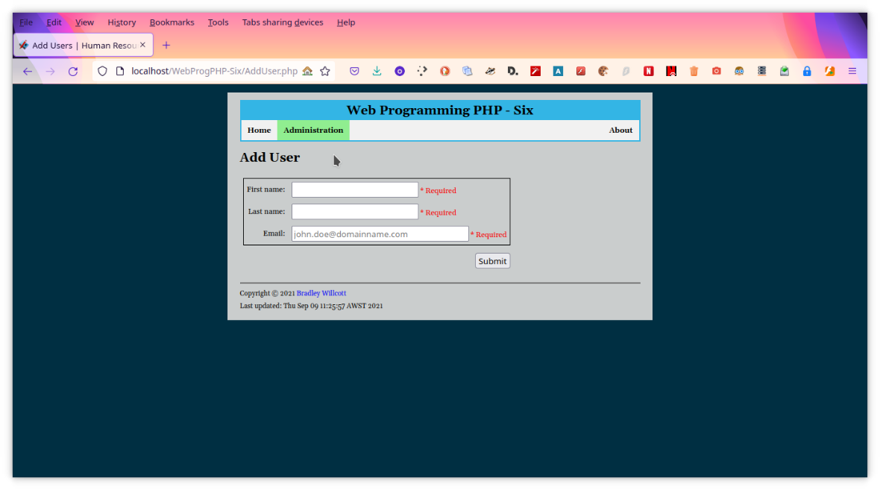

Figure – Add User page - B

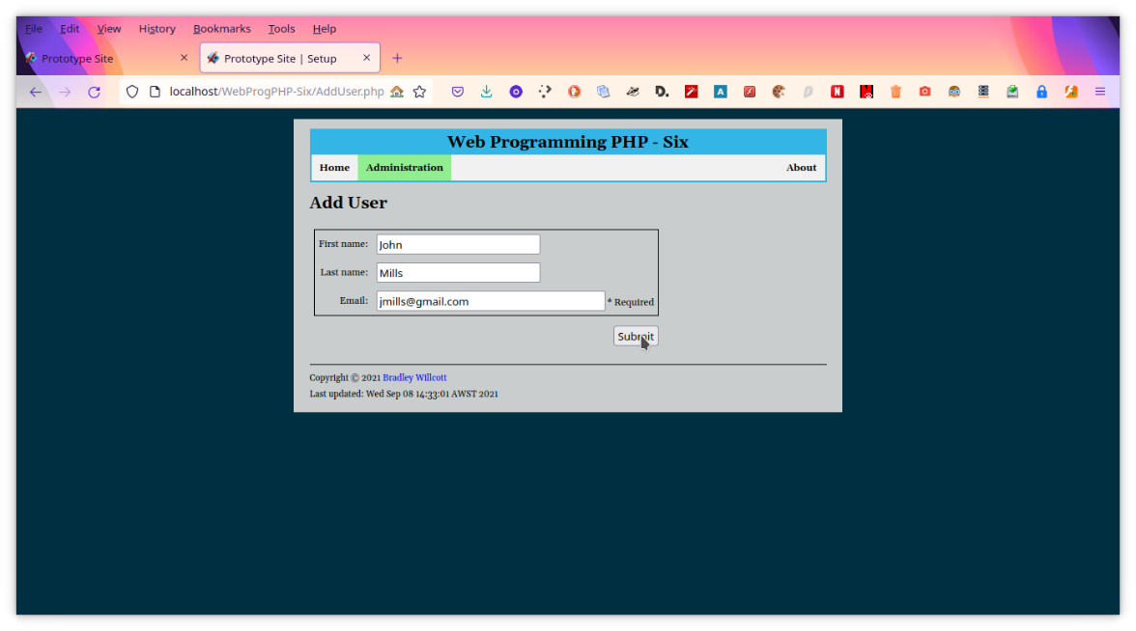

Figure 10 – Add user - A

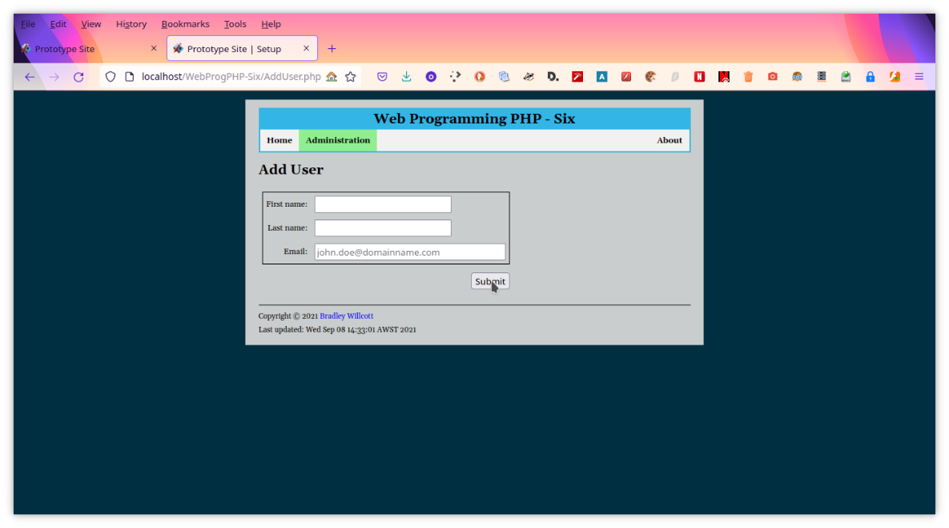

Figure 11 – Add user - B

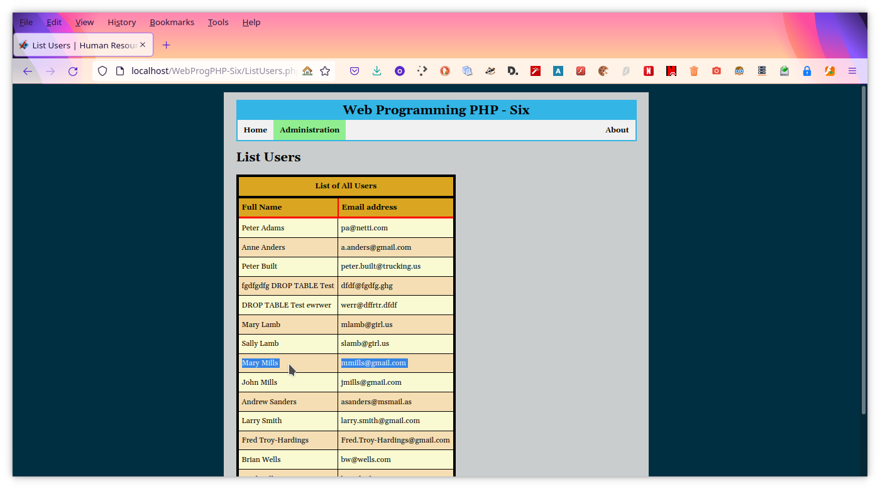

Figure 12 - Add user - C, confirmation

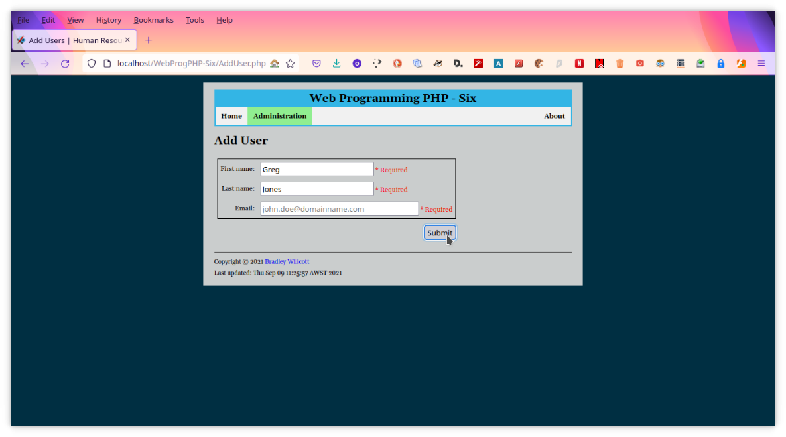

Figure 13 - Partial entry - A

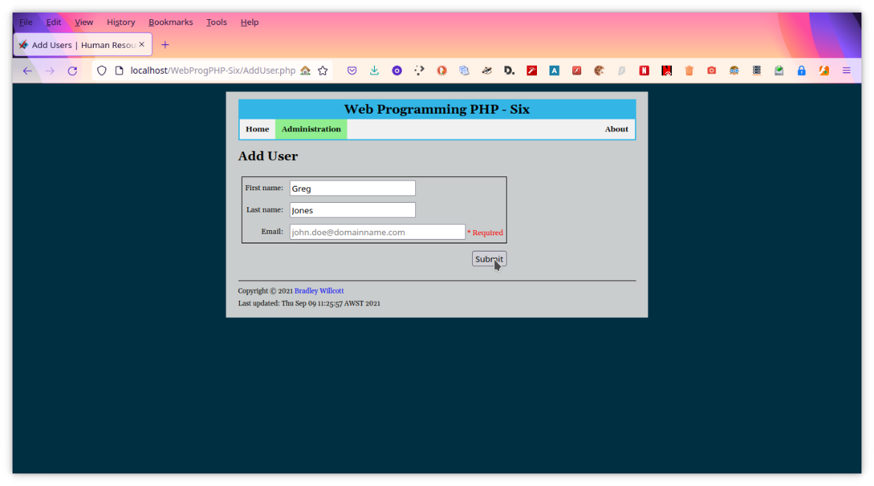

Figure - Partial entry - B

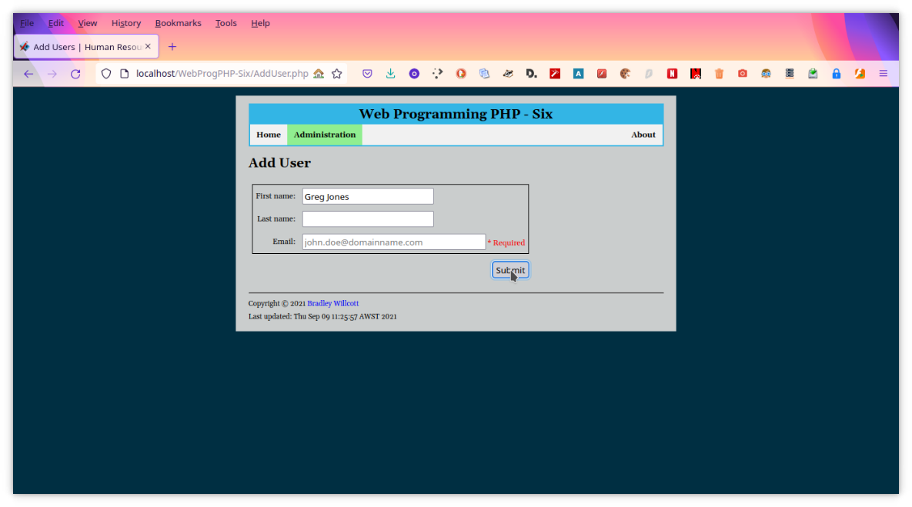

Figure - Partial entry - C

Figure 16 - Partial entry - D

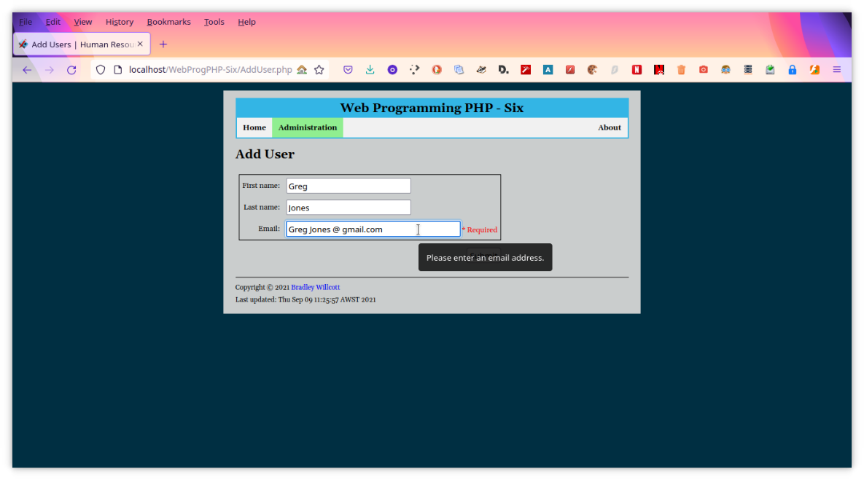

Figure - Invalid email - A

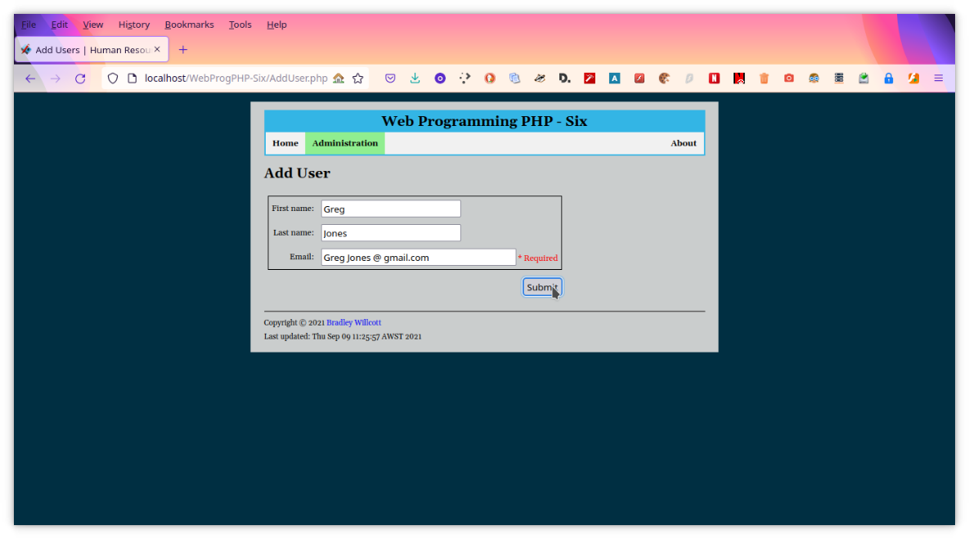

Figure - Invalid email - B

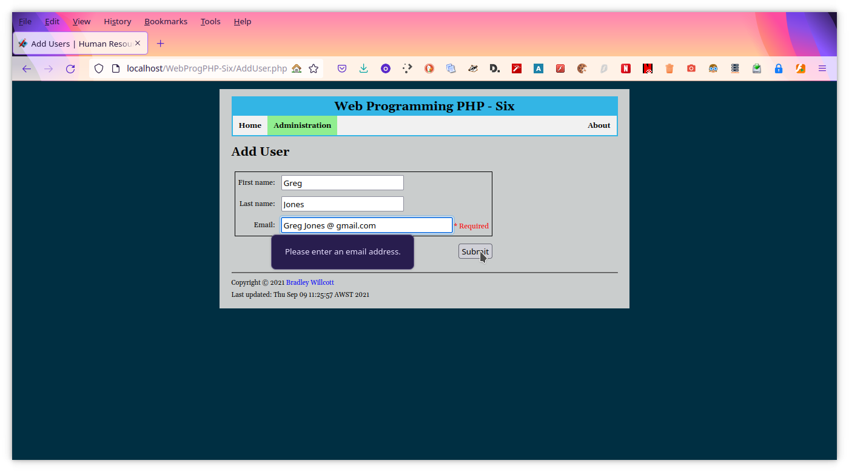

Figure - Invalid email - C

Figure 20 - Invalid text in First name

Figure 21 - Invalid text in Last name

Figure 22 - Go to List Users page

Figure 23 - List Users

Figure 24 - Home page

Figure 25 - Display Add User page - A

Figure 26 - Display Add User page - B

Figure 27 - Add user - A

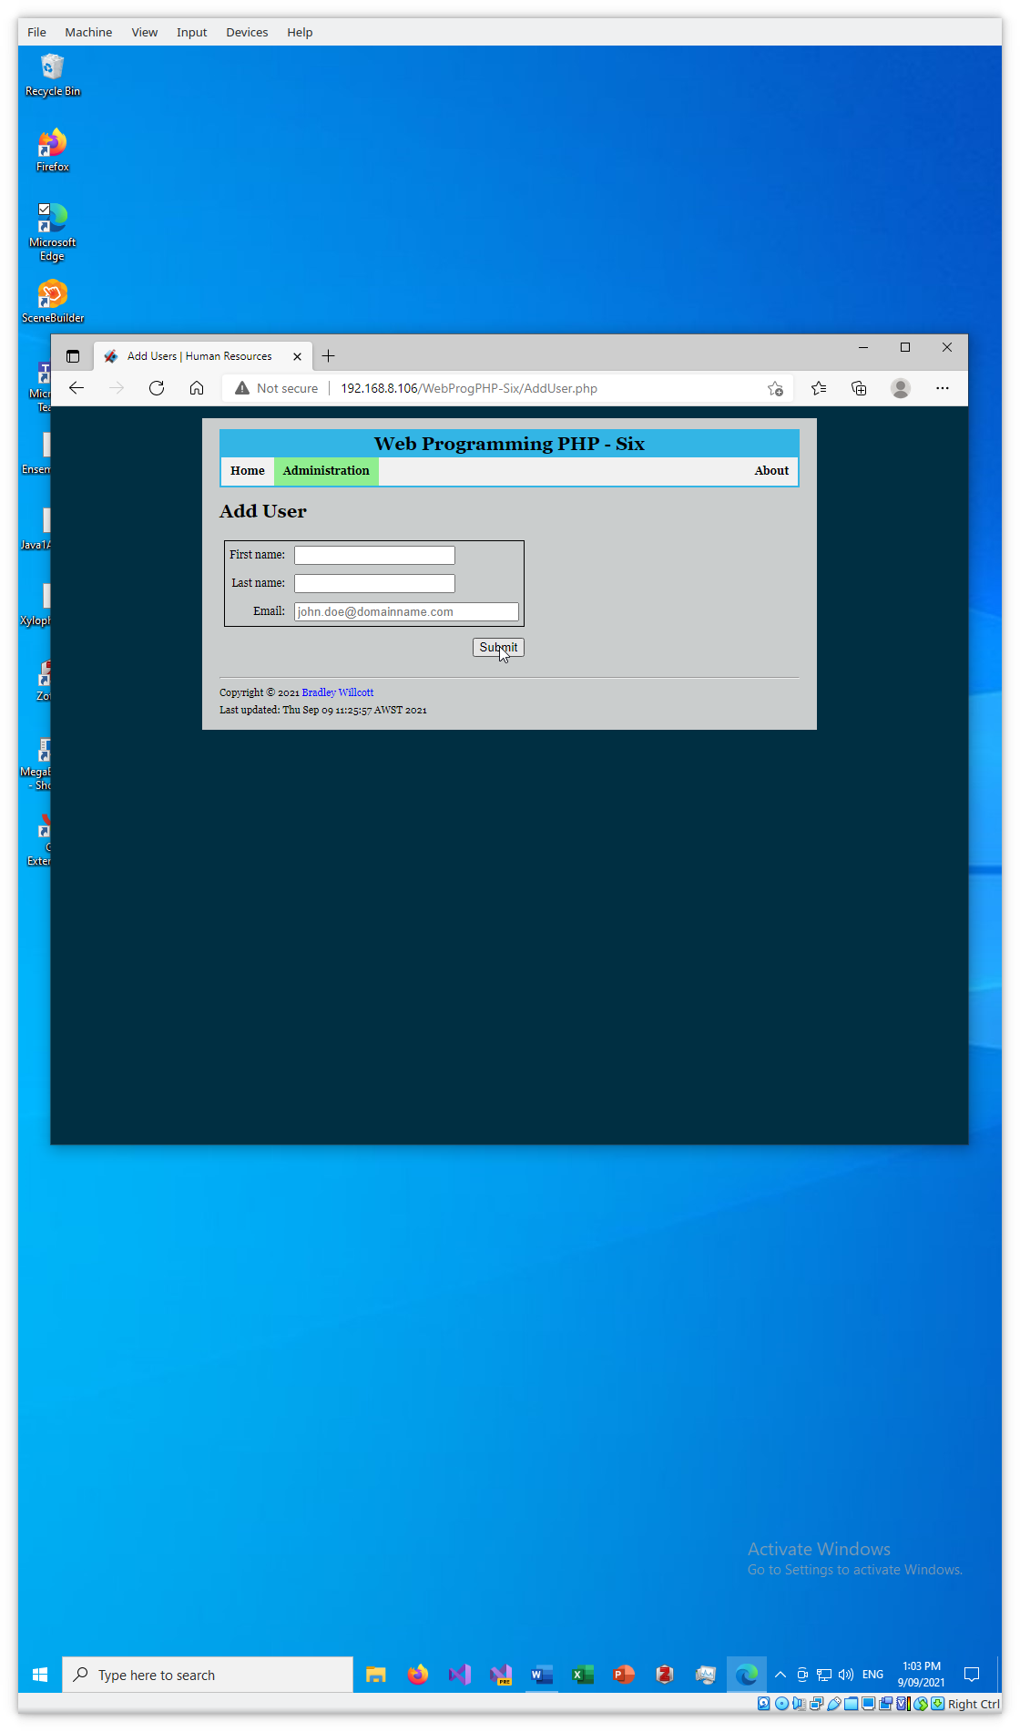

Figure 28 - Add user - B

Figure 29 - Add user - C, confirmation

Figure 30 - Partial data - A

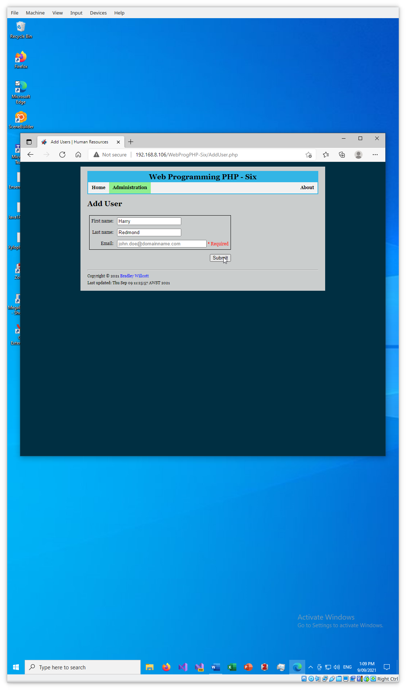

Figure 31 - Partial data - B

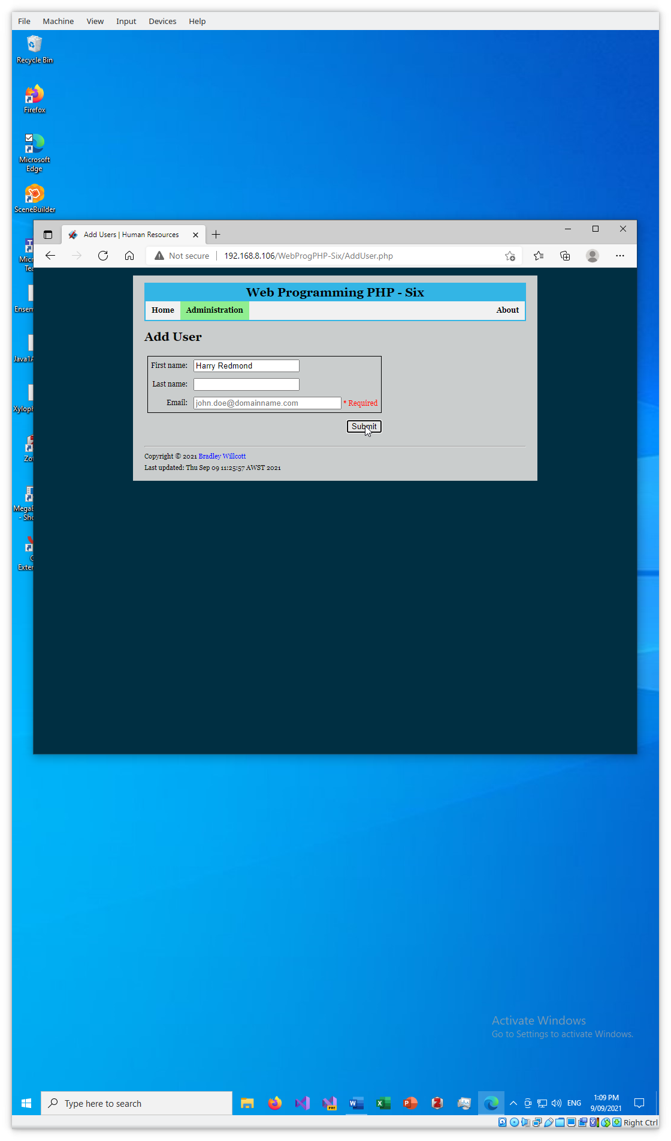

Figure 32 - Partial data - C

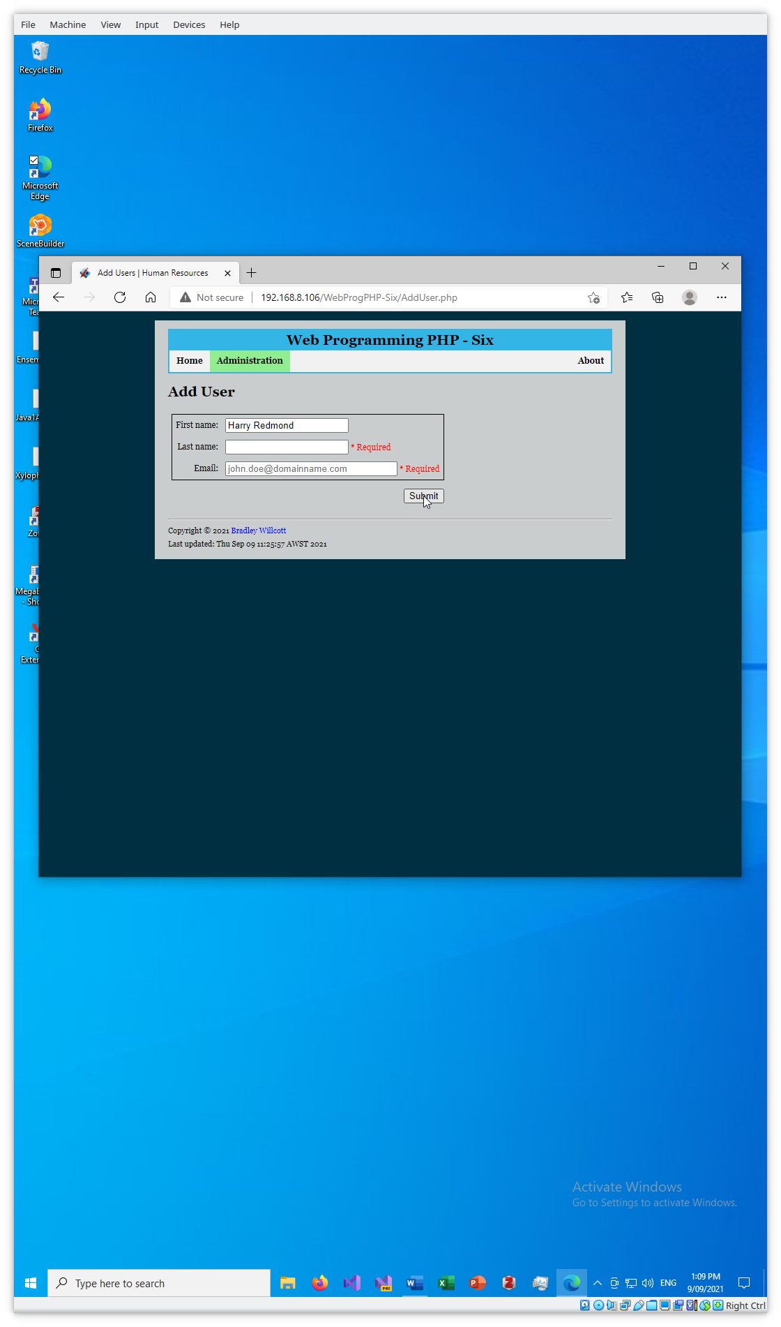

Figure 33 - Partial data - D

Figure 34 - Invalid email - A

Figure 35 - Invalid email - B

Figure 36 - Invalid email - C

Figure 37 - Invalid text in First name

Figure 38 - Invalid text in Last name

Figure 39 - List all users

# References